**SOL 6.4 – Multiplying and Dividing Fractions**

**6.4 The student will demonstrate multiple representations of multiplication and division of fractions.**

### Understanding the Standard:

* Using manipulatives to build conceptual understanding and using pictures and sketches to link concrete examples to the symbolic enhance students’ understanding of operations with fractions and help students connect the meaning of whole number computation to fraction computation.
* Multiplication and division of fractions can be represented with arrays, paper folding, repeated addition, repeated subtraction, fraction strips, pattern blocks and area models.
* When multiplying a whole by a fraction such as (3 x ), the meaning is the same as with multiplication of whole numbers: 3 groups the size of  of the whole.



* When multiplying a fraction by a fraction such as (), we are asking for part of a part.



* When multiplying a fraction by a whole number such as ( x 6), we are trying to find a part of the whole.



* For measurement division, the divisor is the number of groups. You want to know how many are in each of those groups. Division of fractions can be explained as how many of a given divisor are needed to equal the given dividend. In other words, for (), the question is, “How many make?



* For partition division the divisor is the size of the group, so the quotient answers the question, “How much is the whole?” or “How much for one?”



**SOL 6.4 – Multiplying Fractions**

**The Meaning of Multiplication:**

Multiplication is repeatedly adding the same number over and over again. Multiplication makes repeated addition go much faster.



**Examples:** 2+2+2 = 2x3 = 6

7+7+7+7+7+7 = 7x6 = 42

**Thinking about Multiplication:**

|  |  |  |  |
| --- | --- | --- | --- |
| **Expression** | **It is read…** | **It means…** | **What it looks like…** |
| $$2×3$$ |  |  |  |
| $$2×\frac{1}{3}$$ |  |  |  |
| $$\frac{1}{2}×\frac{1}{3}$$ |  |  |  |

**Practical Problems:**

1. The Andersons had pizza for dinner, and there was one-half of a pizza left over. Their three boys each ate one-third of the leftovers for a late night snack. How much of the original pizza did each boy get for snack?

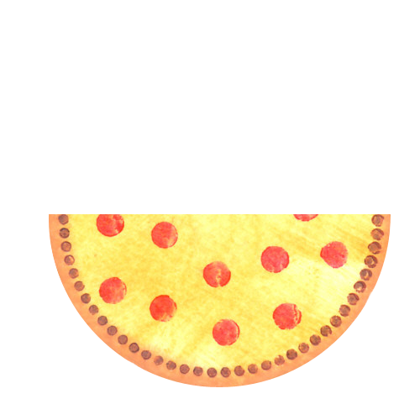

**Answer:** One-third of one-half of a pizza is equal to

one-sixth of a pizza.

$$\frac{1}{2}×\frac{1}{3}= \frac{1}{6}$$

1. Andrea and Allison are partners in a relay race. Each girl will run half the total distance. On race day, Andrea stops for water after running one-third of her half of the race. What portion of the race had Andrea run when she stopped for water?

**Answer:**



1. Mrs. Jones has 24 gold stickers that she bought to put on perfect test papers. She took half of the stickers out of the package, and then she used one-third of that half on the papers. What fraction of the 24 stickers did she use on the perfect test papers?

**Answer:** One-third of one-half of the 24 stickers is one-sixth of the 24 stickers.

$$\frac{1}{2}×\frac{1}{3}= \frac{1}{6}$$

**SOL 6.4 – Dividing Fractions**

**The Meaning of Division:**

Division is repeatedly subtracting the same number over and over again. Division makes repeated subtraction go much faster. Another way to think of division is to fairly share with others, to divvy up, or to split equally.



**Examples:** 6-2-2-2 = 6÷2 = 3

42-7-7-7-7-7-7 = 42÷7 = 6

**What’s the relationship between multiplying and dividing?**

* Multiplication and division are inverse relations



* One operation undoes the other
* Division by a number yields the same result as multiplication by its reciprocal (inverse). For example: $6÷2=6×\frac{1}{2}$



**Thinking about Division:**

|  |  |  |  |
| --- | --- | --- | --- |
| **Expression** | **It is read…** | **It means…** | **What it looks like…** |
| $$20÷5$$ |  |  |  |
| $$20÷\frac{1}{2}$$ |  |  |  |
| $$\frac{1}{2}÷\frac{1}{3}$$ |  |  |  |



**Practical Problems:**

1. The Andersons had half of a pizza left after dinner. Their son’s typical serving size is one-third pizza. How many of these servings will he eat if he finishes the pizza?

**How to solve:** If ⅓ pizza is one serving, how many servings are in the ½ pizza we are starting with in this problem?

Since ⅓ is less than ½, our solution will be more than one serving.

Since the ½ pizza we have is less than ⅔ (or two servings), the solution will be less than 2 servings.

**Answer:** We can portion off one full serving, leaving 1/6 of the original pizza. That sixth is ½ of a serving. We have a total of 1½ servings in our half pizza, that are each ⅓ pizza in size.

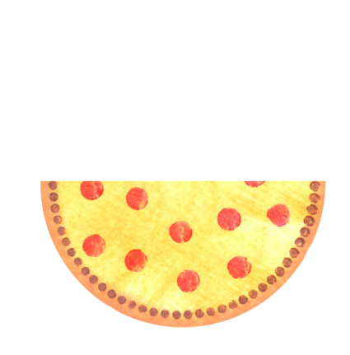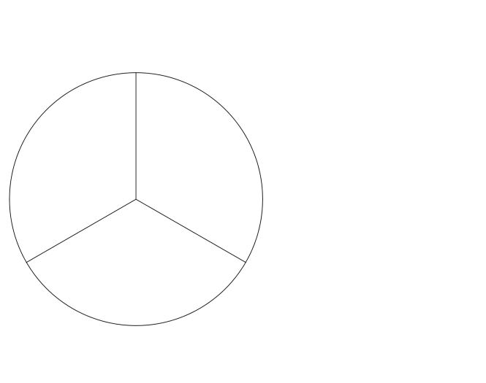

1. Marcy is baking brownies. Her recipe calls for ⅓ cup cocoa for each batch of brownies. Once she gets started, Marcy realizes she only has ½ cup cocoa. If Marcy uses all of the cocoa, how many batches of brownies can she bake?

Three batches (or $\frac{3}{3}$ cup)

1 cup

½ cup

0 cups

$1\frac{1}{2}$ batches

One batch (or $\frac{1}{3}$ cup)

Two batches (or $\frac{2}{3}$ cup)

$$\frac{1}{2}÷\frac{1}{3}=$$

$$\frac{1}{2}×\frac{3}{1}=$$

$$\frac{3}{2}=1\frac{1}{2}$$

1. Mrs. Smith had ½ of a sheet cake left over after her party. She decides to divide the rest of the cake into portions that equal ⅓ of the original cake. How many ⅓ cake portions can Mrs. Smith make from her left-over cake?

**How to Solve:** The blue amount represents the leftover ½ sheet cake.

The green shaded amount shows ⅓ of the original cake.

You can see that one complete ⅓ cake portion exists and then ½ of another portion.

**Another way to think:** common denominators.

We know that ½ is 3-sixths and ⅓ is 2-sixths. How many 2/6 are in 3/6? There is one 2/6 and then ½ of another 2/6, for a total of 1½.

With this diagram you can see that the “little bit more” is really one sixth. So why isn’t “one sixth” a part of the answer? The answer is 1½. Where is that one half in the model?



$$\frac{1}{2}÷\frac{1}{3}= \frac{1}{2}×\frac{3}{1}= \frac{3}{2} =1\frac{1}{2}$$

1. Which product is represented by the shading of the model?



|  |  |  |
| --- | --- | --- |
|  |  | $\frac{2}{3}×\frac{5}{6}$ $\frac{2}{6}×\frac{5}{6}$ $\frac{5}{9}×\frac{2}{9}$ $\frac{5}{18}×\frac{2}{18}$ |
|  |  |  |
|  |  |  |
|  |  |  |
|  |  |  |
|  |  |  |

**Vocabulary:**

**Fraction Multiplication**

How much is $\frac{\text{3}}{\text{8}}$ of $\frac{\text{2}}{\text{3}}$?

=

x



$\frac{\text{3}}{\text{8}} × \frac{2}{3} = \frac{6}{24}=\frac{1}{4}$

**Fraction Division**

How many halves are in three-fourths?

one “whole” half

half

There are 1 $\frac{\text{1}}{\text{2}}$ halves in three-fourths.

$$\frac{3}{4}÷\frac{1}{2}=\frac{3}{4}×\frac{2}{1}=\frac{6}{4}=\frac{3}{2}=1\frac{1}{2}$$

**Fraction Division**

How many halves are in three-fourths?

$$\frac{\text{3}}{\text{4}}\text{÷}\frac{\text{1}}{\text{2}}$$

$\frac{\text{1}}{\text{2}}$ one-half

three-fourths one-half 1 “whole” one-half

There are 1 $\frac{\text{1}}{\text{2}}$ halves in three-fourths.

$$\frac{3}{4}÷\frac{1}{2}=\frac{3}{4}×\frac{2}{1}=\frac{6}{4}=\frac{3}{2}=1\frac{1}{2}$$

**Essential Understandings:**

When multiplying fractions, what is the meaning of the operation?

________________________________________________________________________________________________________________________________________________________________________________________________________________________________________________________________________________________________________________________



What does it mean to divide with fractions?

________________________________________________________________________________________________________________________________________________________________________________________________________________________________________________________________________________________________________________________



**Essential Knowledge & Skills:**

The student will use problem solving, mathematical communication, mathematical reasoning, connections, and representations to:

* Demonstrate multiplication and division of fractions using multiple representations.
* Model algorithms for multiplying and dividing with fractions using appropriate representations.